

Background: #268aae Font size:16px Font family: Fredoka One



Background: #32b5e5 Font size:18px Font family: Fredoka One BOX -SHADOW:XXXX



Color: #32b5e5 Font size:48px Font family: Fredoka One



Color:#ff4a04



Color: #32b5e5 Font size:28px Font family: Fredoka One

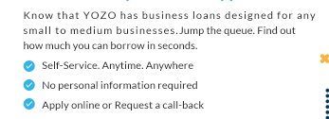

Color: #1c1c1c Font size:22px Font family: Lato

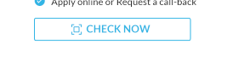

Color: #32b5e5 Font size:24px Font family: Lato Font weight:Bold



Color: #32b5e5 Font size:40px Font family: Fredoka One



Color:#ff4a04



Color: #32b5e5 Font size:28px Font family: Fredoka One



Background: #32b5e5 Font size:28px Font family: Fredoka One



Color: #32b5e5 Font size:20px Font family: Fredoka One

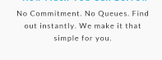

Color: #1c1c1c Font size:18px Font family: Lato



Font size:40px Font family: Fredoka One



Font size:18px Font family: Lato



Font size:22px Font family: Lato Font weight:Bold



Font size:18px Font family: Lato Font weight:Bold



Color: #32b5e5 Font size:40px Font family: Fredoka One



Color:#ff4a04



Color: #1c1c1c Font size:18px Font family: Lato



Background: #32b5e5 Font size:18px Font family: Lato Font weight:Bold